Welcome to the latest newsletter from PAS. View this email in your browser

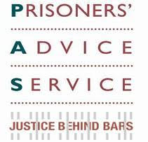Welcome to our June 2016 update.

If you would like further information please go to our website or contact us at admin@prisonersadvice.org.uk

Please follow us on Twitter and like our Facebook page.

Success stories

PAS pursues prisoner’s claim for damages after degrading treatment

We have recently settled a claim for damages on behalf of a prisoner who had been handcuffed during intimate medical procedures while in hospital for a period of some weeks. Furthermore, prison staff had been present during all of his consultations with consultants at the hospital. We argued that the former constituted inhuman and degrading treatment under Article 3 of the European Convention on Human Rights and the latter a breach of the prisoner's right to privacy during consultations under Article 8, the right to respect for his private and family life, his home and his correspondence. This prisoner had approached us through our telephone advice line.

Upholding right to protest peacefully in prison

We were contacted by a large number of prisoners at a high security prison who had been placed on report for having taken part in a peaceful protest. Nineteen prisoners had been objecting to the prison’s repeated failure to deal with ongoing complaints ranging from a lack of basic toiletries to a lack of access to new clothes. They refused to return to their cells at lock-up time until the prison agreed to take their grievances to the governor. They returned to their cells when the prison agreed that this would happen, and the following day prisoner representatives met with a governor and senior manager. However, all the prisoners were subsequently placed on report for failing to return to their cells when ordered to do so. Two were then transferred out of the prison and the other 17 found guilty of the charge, despite detailed submissions from PAS arguing that procedural flaws and breaches of Common Law and the European Convention on Human Rights rendered the charges unlawful. However, following our continued intervention, all the guilty findings, bar one, were successfully appealed to the casework unit in prison service headquarters. We are confident that the outstanding charge will also be quashed by the Prisons and Probation Ombudsman to whom we have referred this case.

PAS secures apology for Muslim prisoner given non-halal meat

A Muslim prisoner complained that the prison he was located in breached his right to practise his religion by giving him food that is forbidden for him to ingest. He had made reasonable enquiries before eating the food, to ensure it was compliant with his religious belief, and he had been assured that it was. It was only later that he found out that the food contained non-halal meat. This upset him greatly, especially as he had enquired first and had been assured the food was suitable for him to eat. We advised him in his complaint against the prison who then admitted their error and apologised to him. The prison also provided assurances that immediate steps have now been taken to ensure that such an incident will not happen again.
News

PAS outreach

As we continue to expand our outreach across the country, in April - May 2016 PAS has had the opportunity to conduct legal advice sessions at three new prisons: Manchester, Kirkham (Lancashire) and Swaleside (Kent). In addition, we have continued to run regular outreach sessions at a further 13 prisons: Belmarsh, Holloway, Pentonville, Thameside and Wandsworth in London; Bronzefield and Send in Surrey; East Sutton Park in Kent; Eastwood Park and Leyhill in Gloucestershire; Lewes in Sussex; New Hall in Yorkshire; and Styal in Cheshire.

PAS in the media
PAS was recently featured in an article in The Guardian and in two letters in Inside Time prison newspaper:

The Guardian: PAS Legal Aid Cuts appeal mentioned in article about new Director of LIiberty

Inside Time: prisoner’s recategorisation

Inside Time: overturning table ban in segregation unit
Events

PAS steps up to London Legal Walk challenge
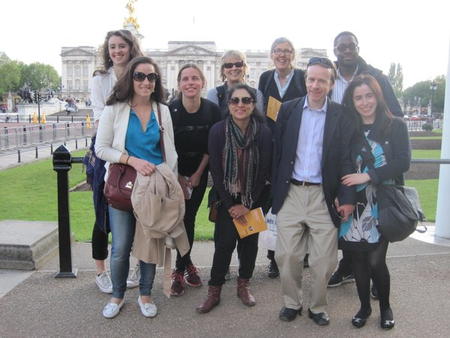In May, staff members and volunteers (pictured right) took part in the 10k London Legal Walk, to help raise funds for vital legal services in London and the South East. Some 10,000 people took part in the walk overall, and collectively covered the same distance as one person walking the Earth’s circumference twice! So far PAS has raised £1,291 towards our work with prisoners through this sponsored walk. We are asking any supporters who have not already done so, to consider kindly donating on our fundraising page here.

PAS 25th anniversary event and panel discussion
In May, we celebrated our 25th anniversary by holding a thought-provoking panel discussion entitled: ‘Discrimination undisclosed: transgender, traveller and older prisoners’ (pictured below):
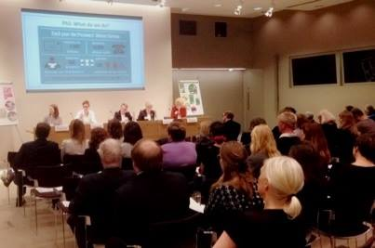

The evening was attended by about 75 guests, who heard contributions from:
- Alma Hageman, Project Worker, HMP Eastwood Park, Resettlement and Care for Older Ex-Offenders and Prisoners
- Dr Sarah Lamble, Senior Lecturer in Law, Birkbeck School of Law
- Geraldine Scullion, Project Manager, Equality and Social Justice Unit, Traveller Movement
- Dr Hazel Wardrop, Research Manager, Equality and Human Rights Commission.
The discussion was chaired by Karon Monaghan QC, Matrix Chambers and took place at the offices of Linklaters LLP, whom we thank very much for their generous support.

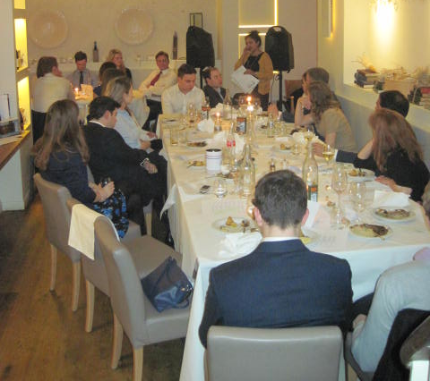PAS speaks at dinner for young lawyers
In March, a representative of PAS spoke about our work at a dinner (pictured left) for the ‘Legal Upstarts’ young lawyers’ group, who kindly raised funds for PAS through the event. We thank the organisers, everyone who attended, and Farrers law firm for their generous support of our work through this event.

Training in universities and corporate law firms
In March, a PAS solicitor delivered a lecture at Kent university on the rights of transgender prisoners. Kent is one of three universities that are operating remote letters clinics for us, drafting replies to prisoners’ queries. The other two universities are Essex and Sunderland. We are grateful for their support which increases our capacity, while providing the law students with valuable legal work experience.

In recent months, we have also provided training on prison law to volunteers at law firms Latham & Watkins, Reed Smith and Shearman & Sterling. These three new corporate pro bono partners join our existing partners: Simmons & Simmons, Herbert Smith Freehills and Mayer Brown. All six firms are operating remote letters clinics for us (similar to the academic project described above). This significantly increases our capacity to respond to prisoners’ written enquiries to us. We are grateful for their support.

Save the Date: PAS Annual Lecture - 3rd November 2016:
We will be holding our Annual Lecture on the evening of Thursday 3rd November 2016. It will be delivered by our patron Edward Fitzgerald QC. Further details will follow in due course, but please save the date in your diaries for now!
Contact Us: PAS, PO Box 46199, London EC1M 4XA
Tel: 020 7253 3323 / Tel: 0845 430 8923 Fax: 020 7253 8067
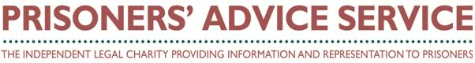Copyright © Prisoners' Advice Service 2015, all rights reserved.
To unsubscribe from this newsletter, please email admin@prisonersadvice.org.uk

