View this email in your browser
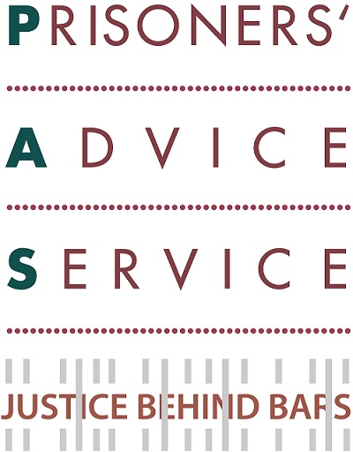

Welcome to our October 2016 update.

If you would like further information please go to our website or contact us at admin@prisonersadvice.org.uk
Please follow us on Twitter and like our Facebook page.

Appeals:

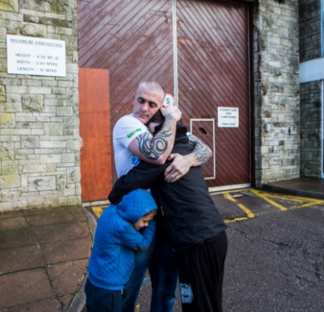
Help us challenge Legal Aid cuts for prisoners
As you may know, in January 2017 PAS and the Howard League for Penal Reform will be challenging the legality of the cuts to legal aid for prisoners in the Court of Appeal. To ensure that the cost of the case does not have an impact on our front-line services, we need to raise £25,000. So we are crowdfunding for the case and we need your help! Please donate £35 or whatever you can by clicking here. Your contribution will be hugely appreciated. Please also e-mail the link to colleagues, friends or family members who might support our appeal and post the link on Facebook and Twitter asking your followers to support us. Thank you so much for your help.

Please vote for us in the Aviva Community Fund Competition
Exciting news: we are taking part in the Aviva Community Fund Competition. We need you to vote please - so that we can become finalists and win up to £5,000 for our work with prisoners with mental, physical or chronic health conditions. All you need to do is follow this link, register with Aviva (takes less than two minutes) and click through on the email they will send you to activate your vote. Then search for ‘prisoners’ and vote for us! Please take a few minutes to let Aviva know that you care about some of the most disadvantaged, vulnerable and powerless adults in our society. Thank you for your help.

Upcoming Events

PAS Annual Lecture – 3 November 6:30-8:30pm
This year’s Lecture will be given by our patron Edward Fitzgerald QC (pictured right) The title is “Life without Parole”. Please join us for drinks and lively discussions. Entry is free. Email events@prisonersadvice.org.uk to register your place. This event is kindly supported by Herbert Smith Freehills.



PAS Pub Quiz – 9 November 6:30-9:00pm
PAS will be participating in the Great Legal Quiz competition organised by the London Legal Support Trust as part of National Pro Bono Week. The quiz will be based on general knowledge (not legal) questions. All the money raised on the night will support PAS’s vital legal advice work with prisoners. There will also be a raffle with some great prizes! We are asking for keen lawyers, brain-boxes, trivia-gurus and loyal supporters of our work, to participate, ideally in teams, and join us upstairs at the Rugby Tavern. To book your place, please click here.

Success stories
PAS helps a released prisoner to return to his family abroad
We received an inquiry via email from a prisoner who had been released and who wanted to contest the requirement that he remain in this country for the duration of his probation licence, instead of being allowed to return to live abroad with his wife and children. We corresponded with the probation service to no avail and eventually issued judicial review proceedings in the High Court, at which point the government solicitors asked probation to urgently reconsider its decision. Faced with the prospect of court proceedings in which they could not defend their decision, probation then made a new decision in our client’s favour. He says: “It should never have come to this and I should have been allowed to leave as soon as I was released, but PAS were amazing sorting it out for me.”

PAS helps a female disabled prisoner to transfer to a suitable prison
Our caseworkers met Prisoner A at an outreach clinic. She has multiple physical and mental health issues including anxiety, Post-Traumatic Stress Disorder, depression and severe Cervical Spondylosis leading to chronic pain and lack of mobility. She was incarcerated in a completely unsuitable prison cell. One of our caseworkers helped her to secure a transfer to a modern prison facility with a modified cell suitable for her needs. She is now eligible for parole, her mental health is much improved and her physical condition is stable. She has commented on our help as follows “PAS supported me all through my sentence and presently has been phenomenal, excellent and immeasurable. I will forever be grateful and sing of PAS services everywhere now and in the future. No matter what.”

PAS helps a prisoner to access vital medication
Prisoner B’s prescription of medication had been stopped for two days despite him making complaints and speaking to the healthcare unit within the prison. He telephoned our helpline panicking and with a racing heartbeat. One of our caseworkers sent an urgent fax whilst another rang the prison and, following our intervention, his prescription arrived later that same day. Prisoner B contacted us shortly afterwards to say thank you.

PAS helps a vulnerable female prisoner to secure specialist legal representation
Our caseworker met a particularly vulnerable female prisoner at a recent outreach clinic. During their consultation, the prisoner disclosed that she had been trafficked to the UK as a young teenager, and since then had been the victim of domestic and sexual abuse. She is a single mother of three children whom she has not seen since she entered custody. Despite this, the government are seeking to deport her on completion of her sentence. Our caseworker has taken on her case on a pro bono basis, and secured her specialist legal representation for her trafficking and immigration matters. The prisoner has sent us two thank you letters since we took on her case: “I would like to take this opportunity to show my appreciation for supporting me in this matter. I am very, very grateful”, “Thank you so much for securing me a legal representative. It means a lot and your support is much appreciated.”

News
Further expansion of PAS outreach clinics
We continue to expand our outreach service across the country. We have recently had the opportunity to restart legal advice sessions at HMP Downview in Surrey. We have also been invited by RECOOP, the charity which supports older prisoners, and with whom we are already successfully working elsewhere, to begin delivering advice sessions at HMP Erlestoke in Wiltshire and HMP Guys Marsh in Dorset. In addition, we have continued to run regular outreach sessions at a further 13 prisons: Belmarsh, Pentonville, Thameside and Wandsworth in London; Bronzefield and Send in Surrey; Eastwood Park and Leyhill in Gloucestershire; Lewes in Sussex; New Hall in Yorkshire; Styal in Cheshire; Kirkham in Lancashire; and Manchester.

Continuing expansion of remote letters clinics
Blackrock’s Legal Department have kindly offered their staff time to set up a further remote legal letters clinic. These remote clinics help us respond to the increasing number of letters we receive from prisoners in need of assistance. Blackrock join our other 6 pro-bono corporate partners: Herbert Smith Freehills, Latham & Watkins, Mayer Brown, Reed Smith, Shearman & Sterling and Simmons & Simmons. We also have remote letters clinics at Kent University, Sunderland University and The University of Essex. To assist in the running of these clinics we have appointed Jane Finnis as our Partnerships Manager as a pilot project (subject to funding). Jane previously provided maternity cover as our Women Prisoners’ Caseworker. Jane will shortly be training a new batch of volunteers at Reed Smith and Mayer Brown. She recently attended the opening of a new purpose built facility for the Law Clinic at Kent University. We are enormously grateful to the 7 corporates and 3 universities which are kindly supporting our work in this way.

New staff members
We are delighted to welcome Buffy Sharpe, our new Trusts Fundraiser. Buffy is responsible for applying to, and liaising with, small and medium sized charitable trusts and foundations. She has 11 years of experience in Trusts and Statutory fundraising and previously worked as a fundraiser for Crisis, Womankind Worldwide and KIS Training. Also joining us for 6 months is Olivia Tattarletti as a trainee solicitor. Olivia is on secondment from Simmons & Simmons. This is the first time PAS has had a secondee and we are very grateful to Simmons & Simmons for this further support. Olivia has already proved to be a great addition to the PAS legal team.

Contact Us: PAS, PO Box 46199, London EC1M 4XA
Tel: 020 7253 3323 / Tel: 0845 430 8923 Fax: 020 7253 8067



Copyright © Prisoners' Advice Service 2015, all rights reserved.
To unsubscribe from this newsletter, please email admin@prisonersadvice.org.uk

