

Welcome to our

December 2016 update.

If you would like further information please go to our website or contact us at admin@prisonersadvice.org.uk
Please follow us on Twitter and like our Facebook page.

Christmas Appeal

Help us challenge the Legal Aid cuts for prisoners

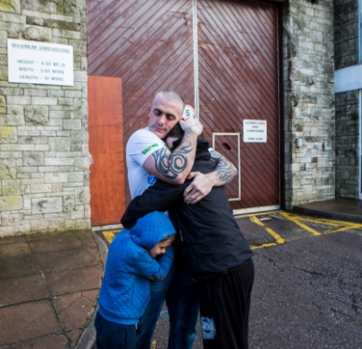
In January 2017, together with the Howard League for Penal Reform, we will be challenging the legality of the cuts to Legal Aid for prisoners in the Court of Appeal. To ensure that the cost of the case does not impact on our front-line services, we have been crowdfunding to raise £25,000. So far we have raised over £9,000. We are very grateful to all who have given generously so far. Donations to our crowdfunding campaign can be made at:

https://www.crowdjustice.org/case/prisoners/

Please support us this Christmas by donating and e-mailing the link to colleagues, friends or family members, and by posting it on Facebook and Twitter asking your followers to support us.

Thank You

Thank you for voting for us in the Aviva Community Fund Competition. We received over 4,000 votes and are through to the next round of the competition! This could see us win up to £5,000 for our work with prisoners with mental, physical or chronic health conditions. Thank you all for your help in getting us to this final stage.
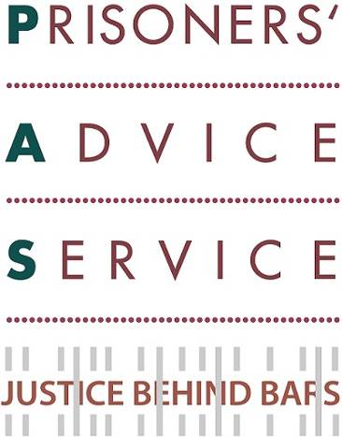


News
PAS Annual Lecture

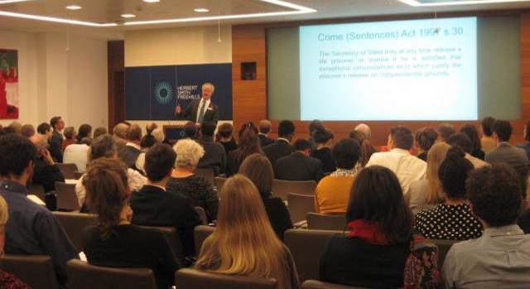
In November, our Patron Edward Fitzgerald QC delivered the annual PAS Lecture (pictured right). This took place in the offices of Herbert Smith Freehills (we are most grateful for their generous support). His speech was entitled “Life without Parole” and was attended by over 100 guests. The full transcript of the lecture is available on our website here, and the Justice Gap’s report on the event is available here.

New Family Law Pilot Project
We are grateful to have recently been awarded grants from the Sir Halley Stewart Trust and The Wates Foundation. They are co-funding us to provide specialist Family Law advice to women prisoners facing potential childcare proceedings. This is a new pilot project in four prisons, in partnership with Lancaster University and the charity Rights of Women. It will help us to provide a more holistic service to women prisoners. The desired outcome of the project is that, despite their imprisonment, mothers will be able to assert their legal rights in relation to their children and engage actively in Family Law proceedings. This in turn will enable them to maintain as active a role as possible in their children’s lives. We hope to reduce the separation of children permanently or temporarily from their families.

PAS Pub Quiz

Quizzes were held all over the country last month to raise funds for Legal Support Trusts and local legal advice charities. The PAS Pub Quiz (pictured right) was held in The Rugby Tavern in Holborn. The event was attended by 40 guests comprising of 8 teams from barristers’ chambers, solicitors’ firms, universities and other loyal supporters of our work. Congratulations to the team from Doughty Street Chambers who came first on the night! The event also included a raffle with some delicious prizes of food and drink. Over £700 was raised to help support our activities.

Self-Help Toolkits for Prisoners
Over the past year, we have been producing a series of 10 Self-Help Toolkits for prisoners - to help them undertake some legal processes by themselves. We have finished the writing and editing phases and will now move into the printing and distribution phases. We will also convert the Toolkits into “Easy-Read” versions - so that those with low literacy levels can benefit from them as well. We are very grateful to The Legal Education Foundation which is funding this much-needed project.

Update on Partnerships
Over the last three months, our partnerships have enabled over 100 additional advice letters to be sent to prisoners. We are grateful to our 7 pro-bono corporate partners which are: BlackRock, Herbert Smith Freehills, Latham & Watkins, Mayer Brown, Reed Smith, Shearman & Sterling and Simmons & Simmons. Some staff at these companies kindly give up their time to participate in remote legal letter clinics - which help us respond to the growing number of prisoners in need of assistance. We have run training sessions in the last quarter with Mayer Brown and Reed Smith for new batches of volunteers in their letters clinics. We also appreciate our partnerships within the academic sector. We will be welcoming the University of Sussex to our partnership scheme in January. We will be training their students in Prison Law - so that they can also take part in a remote letters clinic. Sussex will be joining our 3 current academic partners: the Universities of Essex, Kent and Sunderland. Earlier this month, we attended the opening ceremony (pictured left) for a new building to house the Essex Law & Human Rights Centre Clinics. We have been working with students from the Law Clinic there for the last 2 years. An External Examiner has reported that “The Prison Law casework with PAS is especially conducive to engagement with contextual (moral, social, political) issues, as evidenced by student reflections on their work.” It also allows students to experience the effects of the civil legal aid cuts.

PAS attends ‘CLINKS’ conference
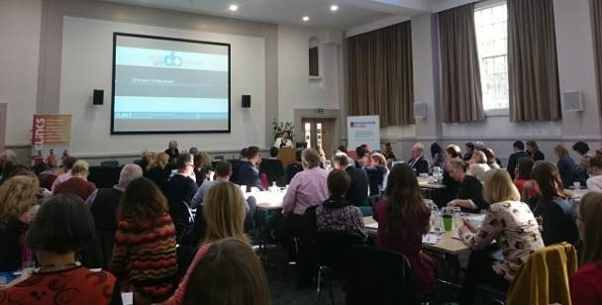
In November, we participated in the CLINKS annual conference (pictured right). CLINKS supports voluntary sector organisations working in the criminal justice sector. This conference discussed the work being carried out, and challenges being faced, by prison sector charities across England & Wales.

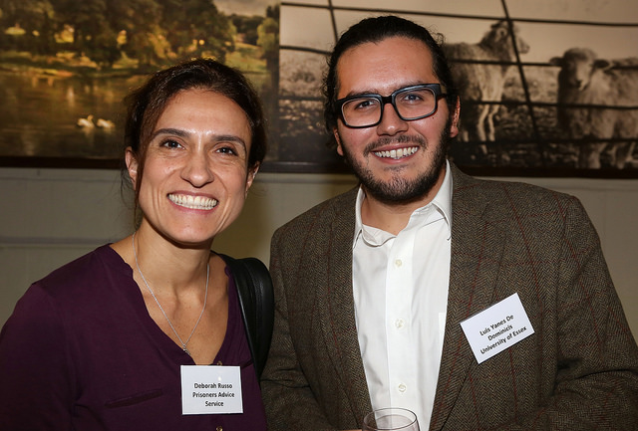
Success Stories
Prisoner finally secures release 12 years after end of tariff
We successfully represented a life-sentenced prisoner at his 7th parole review before a panel of the Parole Board. This prisoner had served almost 19 years in custody, of which nearly 12 years had been served over his tariff (minimum custodial period). He had worked extremely hard whilst in custody to address his offending behaviour. Thanks to his commitment towards his employment on day release from open prison, he had successfully managed to secure an offer of employment for his release. At his parole review, the Parole Board decided that he should now be released. This prisoner had been a long-standing client of ours. We had represented him at 3 of his previous parole hearings and had been instrumental in ensuring his return to an open prison at his 6th parole review, following a complex set of circumstances.

Elderly disabled prisoner secures release to supportive accommodation
We represented a prisoner serving an Indeterminate Sentence for Public Protection, who had some learning disability and mental health issues. He had been unable to engage with offending behaviour courses because of his cognitive issues. He was 5 years over tariff and was unable to do anything more to reduce his risk in prison. Although he had been stable for some time, the Parole Board had, at his last review, expressed concern that without support he remained a risk to himself or others. As an elderly man, he faced spending the rest of his life in prison. We referred him to specialist accommodation, where he could be supported and supervised in the community. We also secured agreement from the local authority to fund the placement. Thanks to our intervention, his Probation Officer approved the placement in advance of his parole review and made detailed plans for release. These were presented to the Parole Board at an oral hearing and the Board directed his release.

Dying prisoner gains compassionate release
Prisoner B was a life-sentenced prisoner who was diagnosed with terminal cancer. Prisoner B had received treatment for cancer some years earlier but was thought to be in remission. Unfortunately the cancer had spread to many areas of Prisoner B’s body, giving the prisoner only a few months left to live. We assisted Prisoner B, on a pro bono basis, to make an application to the Secretary of State for Justice for early release on compassionate grounds. The prison supported release, but found it difficult to obtain all the evidence required for the Ministry of Justice. We tirelessly pursued documents, without which the application would have likely failed. Following many weeks of hard work, the application for compassionate release was submitted for consideration by the Justice Secretary and then the Parole Board. The application was granted, and thanks to our intervention, Prisoner B was able to spend their last days at home with family.

Merry Christmas!
Thank you for all your support during 2016. We wish you all a Merry Christmas and a Happy New Year! Best wishes for 2017.

Contact Us: PAS, PO Box 46199, London EC1M 4XA.
Tel: 020 7253 3323 / Tel: 0845 430 8923 Fax: 020 7253 8067


Copyright © Prisoners' Advice Service 2015, all rights reserved.
To unsubscribe from this newsletter, please email admin@prisonersadvice.org.uk

