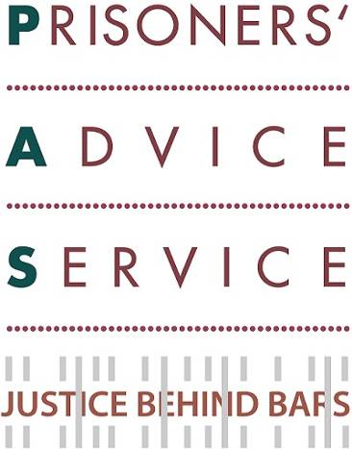

Welcome to our March 2017 update.

If you would like further information please go to our website or contact us at admin@prisonersadvice.org.uk
Please follow us on Twitter and like our Facebook page.

Appeal

Next month, Emily Martin of Doughty Street Chambers is kindly running the London Marathon on behalf of PAS; all funds raised will go towards our work with prisoners. Please support our activities by kindly sponsoring her efforts here.

Save the Date

Our annual panel discussion will be held on the evening of Wednesday 24th May 2017 exploring the topic “Sentencing Mothers - The Trickle-Down Effects”. The discussion will be held at the offices of CMS Cameron McKenna (whom we thank for their support) from 6 to 9pm. The speakers will be:

Lucy Baldwin – Senior Lecturer in Criminology, De Montfort University; and author of ‘Mothering Justice’

Jenny Earle – Director of Reducing Women’s Imprisonment Programme, Prison Reform Trust
Paula Harriott – Head of Involvement, Revolving Doors; and ex-prisoner

Renuka Jeyarajah-Dent – Director of Operations, Coram; and educational psychologist

Sam Genen – Solicitor; and leader of Women’s Sentencing Project, Centre for Criminal Appeals

Phillippa Kaufmann QC – Chair of Panel; Matrix Chambers

We are not yet taking bookings for this event (the formal invitation and booking process will follow), but we encourage you to save the date if you are interested in this topic.

News

Media Coverage of our Legal Aid Cuts Judicial Review

In January, together with the Howard League for Penal Reform, we challenged the legality of the cuts to Legal Aid for prisoners in the Court of Appeal. Judgement was reserved and the verdict is still awaited. The case has featured in articles on The Guardian and The Huffington Post. Our press releases about these developments can be found on our website.

Initiating our new Family Law Project
Our new project, in collaboration with Lancaster University and Rights of Women, to provide Family Law advice and advocacy services to mothers in prison is getting underway. The training of two of our Caseworkers in Family Law by Rights of Women has now begun. Last month, several members of our project team met with representatives of the funders: the Sir Halley Stewart Trust and the Wates Foundation (pictured right) to discuss the implementation of the 3 year project. We are extremely grateful for their support.

New Partnership with Sussex University
We have continued the expansion of our remote letters clinics, the latest addition being the University of Sussex. Some students there will offer assistance with our letters advice service. We train the students on prison law in order for them to draft responses to prisoners’ letters and advice requests. The principal aim of the remote clinics is to provide assistance and increased capacity for PAS in the form of additional legal volunteers at remote locations, in the context of growing demand for our services from prisoners. The remote clinics also benefit the participating students by giving them hands-on experience in prison law and the drafting of legal letters. The University of Sussex joins our existing academic partners: the Universities of Kent and Sunderland. We are also grateful to our 7 pro-bono corporate partners, involved in a similar scheme, which are: BlackRock, Herbert Smith Freehills, Latham & Watkins, Mayer Brown, Reed Smith, Shearman & Sterling and Simmons & Simmons.

Great Legal Bake Sale
Last month, we participated in the Great Legal Bake Sale, organised through the London Legal Support Trust. Our staff and volunteers baked cakes (pictured right) that were kindly bought by local solicitors firms and barristers chambers. We managed to raise nearly £900 through this initiative. Thank you for your support!


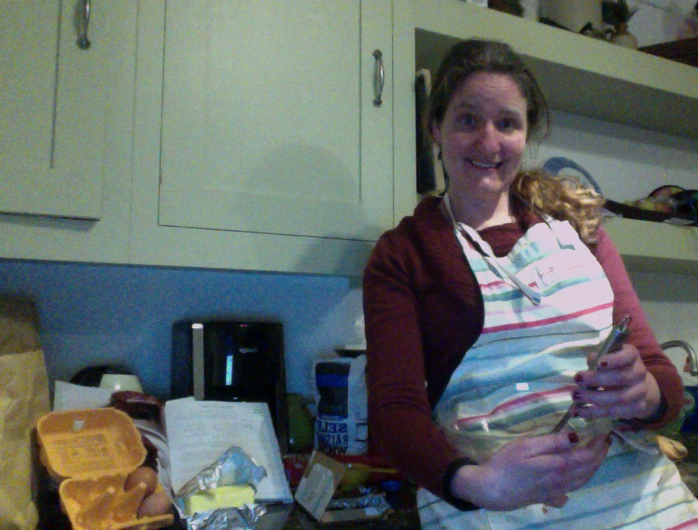
Office Move and Staff Changes
Before……
After!

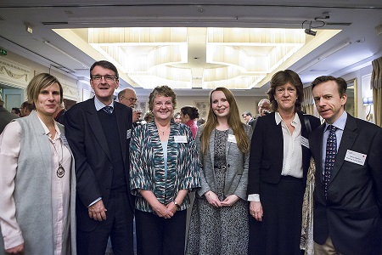
After 13 years, PAS will be packing up and leaving our humble offices in Farringdon. Next month, we will move just a stone’s throw away to a new office in Clerkenwell! Sadly, we will be saying goodbye this month to two valuable members of the team: our legal secondee from Simmons & Simmons, Olivia Tattarletti, and our Fundraising and Communications Director for the last three years, Adrian Gannon. We warmly welcome Adrian’s replacement – Geof Jarvis and we wish both Olivia and Adrian the very best for the future. Olivia was our first ever secondee and we are incredibly thankful to Simmons & Simmons to have given PAS, and Olivia, such a valuable opportunity. We are therefore keen to host other secondees in the future. If you are - or your organisation is - interested in this opportunity, please email our Partnerships Manager for further details: jane.finnis@prisonersadvice.org.uk

Success Stories
Obtaining transfer for a vulnerable detainee to an Immigration Removal Centre (IRC)
Prisoner A was on an immigration hold in prison, having served his custodial sentence. While detained, he was stabbed in the chest in an incident severe enough for the police to be called. He was subsequently moved to another wing in the prison but continued to receive threats from his attacker and feared for his safety. On behalf of Prisoner A, we wrote to Home Office Immigration Enforcement to request a transfer to the immigration removal estate as a matter of urgency, as he was not a violent or serious offender. The Home Office refused the move at first, giving inadequate reasons for the refusal. We wrote again, reminding the Home Office of its duty of care to Prisoner A. A transfer was subsequently promised, and we continued to pursue the matter for two weeks until transfer was completed and we could confirm his arrival at the IRC. During this time, we also provided information on the progress of the transfer to Prisoner A’s wife who was concerned for his safety but not able to communicate easily with him in prison. He was finally transferred to an IRC where he could easily access free legal support concerning immigration law issues and speak with his family.

Helping to appeal an unfair decision to recall a prisoner for breaching her licence
Prisoner B had served the minimum 12 years of her life sentence, had been released and had begun to rebuild her life. After two years, she was recalled into custody for breaching licence conditions and spent six months back in prison. We could clearly see that the decision to recall her was made upon false allegations of a criminal offence that had no substance. We represented her at a hearing before the parole board and helped secure her release.

Ensuring a prisoner suffering from cancer retains his chance to have children
Prisoner C was suffering from cancer. He was due to have a lifesaving operation within a week that would render him infertile. He wanted to provide a sample that would enable him and his partner to undergo fertility treatment in the future. To refuse this would prevent them from ever being able to have children. The prison had told him he was not allowed to give a sample and that they could not confirm it would be agreed to in time for the operation. We made representations to the Governor and Secretary of State and liaised with both. Following our intervention, confirmation was given that Prisoner C would be allowed to provide a sample to be saved by the hospital for future use after his operation.

Contact Us: PAS, PO Box 46199, London EC1M 4XA.
Tel: 020 7253 3323 / Tel: 0845 430 8923 Fax: 020 7253 8067



Copyright © Prisoners' Advice Service 2015, all rights reserved.
To unsubscribe from this newsletter, please email admin@prisonersadvice.org.uk

#

