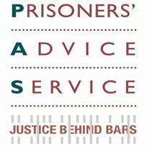
HMP Thameside

Welcome to our Winter Update. If you would like further information or to donate to PAS please go to our website or contact us admin@prisonersadvice.org.uk.

Prisoners’ Advice Service News Update
_____________________________________________________________
News

The human rights that prisoners have been able to assert since the 1990s are under attack, with drastic cuts to legal aid meaning that they can no longer seek legal advice or representation on most legal matters. PAS and the Howard League are challenging the devastating cuts by judicial review. We have also issued proceedings specifically because the government failed to consult before enacting these severe cuts. We are disappointed that the Secretary of State for Justice has refused to take on board our concerns and left us with no choice but to issue proceedings.
____________________________________________________________________________
We have issued judicial review proceedings against the Ministry of Justice following their decision to remove legal aid for a small number of important parole board cases without consultation. These cases are known as ‘pre-tariff reviews’ and affect prisoners on indeterminate sentences who could be moved to open conditions following a parole board hearing. As far as we are aware, nobody, including the parole board, was in a position to alert the government to the risks of removing funding for this work before the decision was made.
____________________________________________________________________________
Two of our caseworkers hosted a stall at the Progressing Prisoners Maintaining Innocence conference on Saturday 16 November 2013, which was an informative day on an important issue for many prisoners.
____________________________________________________________________________
A PAS caseworker will attend and speak at Leeds University Event on 2 December 2013. This is in conjunction with the Human Rights Lawyers Association and aimed at law students interested in a career focused on human rights.
____________________________________________________________________________
We are adding to our outreach programme with a new free Legal Advice Clinic at HMP Thameside in the new year.
____________________________________________________________________________
Matthew Evans has left PAS and joint Managing Solicitors Lubia Begum-Rob and Deborah Russo have been appointed. Naomi Lumsdaine is now the Women’s Caseworker.

PAS’ AGM is on 9 December and this year is kindly hosted by Garden Court Chambers.
____________________________________________________________________________
PAS will be broadcasting an appeal on BBC Radio 4 on Sunday 5 January 07.55 & 21.26 and Thursday 9 January at 15.27– please listen out for us!

____________________________________________________________________________
Success Story

John is a prisoner in an open prison. He had had several releases on temporary licence planned but none that coincided with his wife’s due date and he very much wanted to be present at the birth of his child. We advised him to apply for a Special Purpose Licence (SPL) for when she went into labour, which neither he nor the prison had known was an option. We contacted the prison to request that they consider an SPL for this purpose as soon as possible, in light of the prisoner’s exemplary behaviour and the importance of maintaining family ties. Three days later John’s wife was admitted to her hospital maternity unit. She contacted the prison and within a couple of hours he was released on SPL and went straight to the hospital. He was able to be with his wife at this crucial time and remained with her and the baby in the hospital for 48 hours before returning straight to the prison.
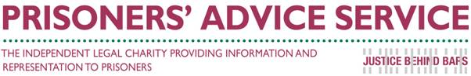Address Telephone
PAS Tel: 020 7253 3323
PO Box 46199 Tel: 0845 430 8923
London Fax: 020 7253 8067
EC1M 4XA

