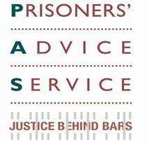
Welcome to our August Update. If you would like further information please go to our website or contact us admin@prisonersadvice.org.uk

Prisoners’ Advice Service News Update

Success Stories
Bereavement Support
Prisoner A was at HMP East Sutton Park, where we met her at a recent outreach clinic. She was extremely distressed at the death of her younger sibling (to whom she had been very close). However, she had not received any support or assistance from the prison regarding her bereavement issues. We wrote to the prison to highlight her distress and the prison’s failures to provide proper counselling, etc. As a result of our intervention, Prisoner A was transferred to HMP Send where her issues are now being better addressed through support from the prison Chaplaincy and some much needed bereavement counselling. She has recently written to thank us for our assistance and reported that it has really helped her in moving forward after this loss.

Protection from Intimidation
Prisoner B was suffering intimidation by his co-defendants, after they were all convicted and sent to the same prison, awaiting transfer elsewhere. He had his Enhanced privileges removed because he had refused to leave the wing or go to work because of the intimidation. Following a letter to the prison from PAS, he is being sent to a different prison from the others, in which they are never likely to be put. Prisoner B also has been reinstated to Enhanced status and has got a prison job back.

News

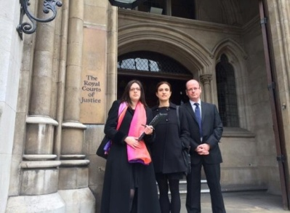
PAS Judicial Review Appeal Allowed
The Court of Appeal notified the Prisoners’ Advice Service and the Howard League for Penal Reform in July 2014 of its decision to allow an appeal of the High Court’s decision to refuse the charities permission to judicially review the Lord Chancellor’s substantial cuts to legal aid for prisoners. The original challenge had been dismissed by the High Court in March 2014, on the basis that the claim was not arguable. The Court of Appeal has granted the appeal on the basis that there are sufficient prospects of success. The challenges concern the decision to cut most aspects of prison law from legal aid funding, leaving even young and mentally ill prisoners without legal protection and, in some cases, facing parole board reviews alone. You can read the Law Society Gazette report on this here. We expect the decision in the Autumn.
Representatives of PAS and the
Howard League at the High Court during judicial review process

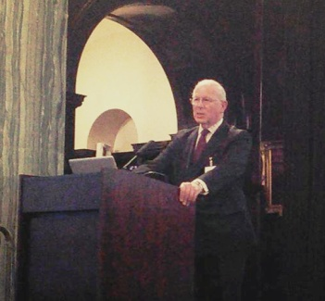
PAS debate on Legal Aid
We held a successful debate at the Law Society in May which was attended by 100 people. The topic was ‘Can the Rule of Law Survive Without Legal Aid?’ The debate was chaired by:
- Raphael Rowe, BBC Panorama journalist; with speakers:
- His Hon John Samuels QC, Judicial Member of Parole Board and former Circuit Judge
- Simon Creighton, Partner at Bhatt Murphy and former PAS Solicitor
- Lucy Scott-Moncrieff CBE, Director of Scott-Moncrieff & Associates, former Law Society President
- Carol Storer OBE, Director, Legal Aid Practitioners Group
- Leroy Skeete, Campaigner, Mentor and former PAS client.
The Justice Gap wrote an article on the event, which you can read here.
Judge John Samuels QC
speaking at our legal aid
debate in May

Thank you (and 50% matched funding offer!)
Firstly, a massive thank you to everyone who has kindly donated to our on-line fundraising appeal - to support our work with women prisoners and disabled prisoners. So far, we’ve raised £6,245. This is terrific!, and we're very grateful for your support. The web-link to read more about our project, and to donate, is here.

Secondly, the organisers at Global Giving have kindly offered to 50% match fund any donations made in the first week of September. So, if you haven't yet donated, and would still like to, or would like to take advantage of this offer, please do so on 1st September or ASAP after that, and your gift will be worth 50% more!

New Outreach Service in HMP Belmarsh
We are launching a monthly legal advice clinic in HMP Belmarsh from September. This will be the 7th prison in which we are currently providing legal advice clinics, alongside: HMPs East Sutton Park, Holloway, Pentonville, Send, Thameside and Wandsworth.

HMP Belmarsh
Please sponsor our caseworkers’ run
Caseworkers Nicki Rensten and Deborah Russo recently ran the British 10k Run in aid of PAS. Both successfully completed the race, and we would be very grateful for any retrospective sponsorship for their admirable efforts. You can donate here.



Prisoners’ Advice Service  PO Box 46199  London EC1M 4XA |  | Tel: 020 7253 3323  Tel: 0845 430 8923  Fax: 020 7253 8067


